Automated Web Scanner

Cybersecurity Bootcamp Project Report

Prepared by: Shriti Kumari
Project type: Educational cybersecurity tool

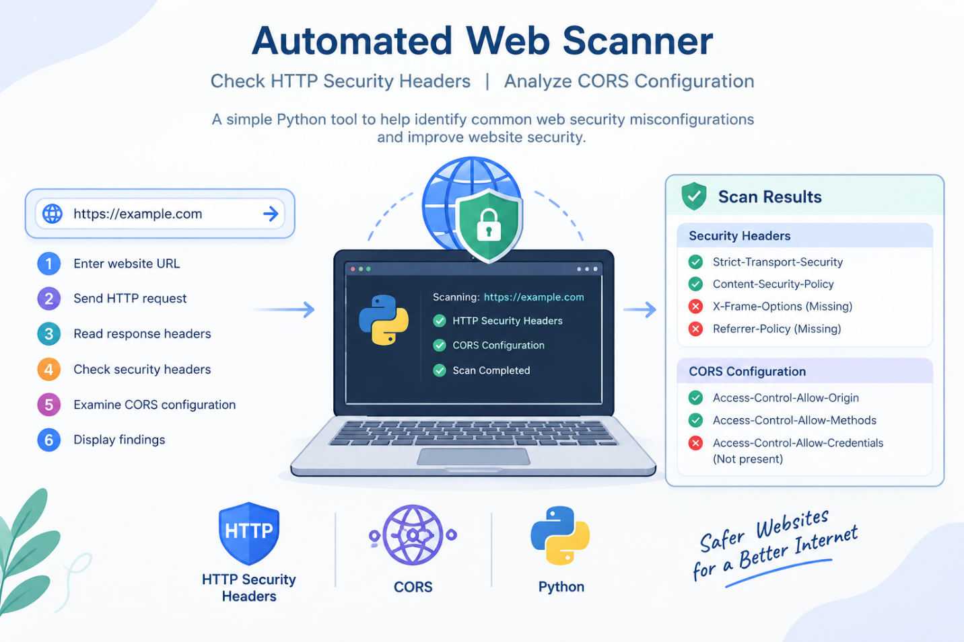

1. Abstract
The Automated Web Scanner is a basic Python-based tool designed to inspect selected HTTP security response headers and report visible Cross-Origin Resource Sharing (CORS) response headers. It accepts a website URL, makes a single HTTP GET request, presents observations in a console report, and can save findings as a JSON file. It is intended for learning and basic configuration review; it does not perform a full penetration test or prove that a website is secure or vulnerable.
2. Introduction
Web applications communicate with browsers using HTTP responses. Response headers can provide security-related controls, while CORS headers describe how browsers may allow cross-origin access to resources. Reviewing these headers can help developers identify configurations that may need further assessment.
3. Problem Statement
Checking security-related response headers manually can be repetitive. This project provides a simple command-line utility that displays selected headers, explains their general purpose, and records basic observations for later review.
4. Objectives
Accept and validate a website URL.
Check whether selected HTTP security headers appear in the response.
Display selected CORS response headers and explanatory notes.
Handle common URL, connection, timeout, and TLS-related errors.
Optionally save scan findings as a timestamped JSON report.
Encourage authorized testing and communicate the tool's limitations.
5. Tools and Technologies
Python — programming language used to implement the scanner.
requests — sends the HTTP GET request and provides access to response headers.
socket — resolves the hostname before the request.
ipaddress — checks whether resolved IP addresses are public addresses.
urllib.parse — parses URL components.
json — writes scan results to a JSON report.
pathlib — creates and manages the report output path.
datetime — adds timestamps to scan results and report filenames.
6. How the Scanner Works
URL input and validation: accepts a URL, adds HTTPS when no scheme is supplied, and rejects unsupported schemes or URLs containing credentials.
Host validation: resolves the hostname and rejects localhost or hostnames resolving to non-public addresses.
HTTP request: sends one GET request with a timeout and does not follow redirects.
Security-header review: checks Strict-Transport-Security, Content-Security-Policy, X-Content-Type-Options, X-Frame-Options, Referrer-Policy, and Permissions-Policy.
CORS-header review: displays observed Access-Control-Allow-Origin, Access-Control-Allow-Credentials, Access-Control-Allow-Methods, Access-Control-Allow-Headers, and Vary values, with cautious explanatory notes.
Results and export: prints a console report and can save findings to a timestamped JSON file inside a reports folder.
7. Implementation Overview
The program uses functions for URL normalization, public-host validation, CORS interpretation, website scanning, console reporting, JSON export, and program execution. A timeout is used for network requests, redirects are not followed, and TLS certificate verification is not disabled. The response body is read with a size limit because the tool primarily needs response metadata and headers.
8. Testing Plan and Results
The code includes handling for several expected situations, but actual test outcomes should be recorded only after running the program. Test only websites you own or have explicit permission to assess. Do not claim a test passed unless you observed the result.
9. Limitations
The scanner checks a limited set of response headers only.
It makes one ordinary GET request and does not follow redirects.
A missing security header is not automatically proof of a vulnerability.
The CORS review is a basic response-header inspection, not a complete browser-based CORS test.
It does not crawl a site, test authentication, inspect application logic, or detect all security weaknesses.
Results depend on the response received at the time of scanning.
10. Ethical and Safe Use
Use this educational tool only on websites you own or have explicit permission to assess. The scanner is intended for non-intrusive configuration review. Follow applicable laws, organizational rules, and the website owner's testing policy.
11. Conclusion
This project demonstrates how Python can automate a basic review of HTTP security headers and CORS response headers. It also demonstrates URL validation, network error handling, console reporting, and JSON export. The output is an initial observation that may guide further authorized review, not a definitive security verdict.
12. Future Scope
Add a clearer remediation guide while avoiding unsupported vulnerability claims.
Create a CSV or HTML export option.
Add automated unit tests for URL validation and header interpretation.
Document the tested Python and requests versions.
Add a simple user interface if required by the project scope.
Test Cases to Complete After Running the Program
Test case | Expected behaviour | Observed result
Authorized public website | Displays HTTP status and header observations. | To be completed after testing
URL without scheme | Attempts to normalize it to HTTPS. | To be completed after testing
Invalid/unresolvable hostname | Shows a validation or connection message. | To be completed after testing
Slow/unreachable website | Handles timeout or connection errors. | To be completed after testing
Save report option selected | Creates a timestamped JSON file. | To be completed after testing
Note: This report is based on the supplied Python source file. Testing results are marked as pending because execution results were not provided.

